**Math 120  
4.3 Properties of Logarithms**

# Objectives:

1. Use the product rule.
2. Use the quotient rule
3. Use the power rule.
4. Expand logarithmic expressions.
5. Condense logarithmic expressions.
6. Use the change-of-base property.

# Topic #1: Properties of Logarithms – The Product Rule

Since logarithms are exponents in reverse, certain properties of exponents apply to logarithms too. Recall the definition of logarithm:

The product rule for exponents states:

This indicates that to **multiply** like base exponents means to **add** the powers.

The Product Rule for logarithms is similar:

This also indicates that multiplication becomes addition.

For example, we can expand a logarithmic expression that involves multiplication:

*Example #1* – Expand the Expression and Simplify when Possible

a) $\log_{6}\left(7*3\right)$

The product of $7$ and $3$ is an input to the operation “log base 6” and the product rule applies:

b) $\log\left(10000x\right)$

The product of $10000$ and $x$ is an input to the operation “log base 10” and the product rule applies:

The first term of the expansion can be simplified since ${10}^{4}=10000$:

c) $\ln\left(10e^{2}\right)$

The product of $10$ and $e^{2}$ is an input to the operation “log base $e$” and the product rule applies

The second term of the expansion can be simplified since a natural log (base $e$) undoes a base $e$ exponent:

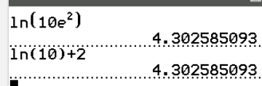

# Topic #2: Properties of Logarithms – The Quotient Rule

The quotient rule for exponents states:

This indicates that to **divide** like base exponents means to **subtract** the powers (in order).

The corresponding Quotient Rule for logarithms is similar:

This also indicates that division becomes subtraction.

For example, we can expand a logarithmic expression that involves division:

*Example #1* – Expand the Expression and Simplify when Possible

$$\text{a) }\log_{9}\left(\frac{9}{y}\right)$$

The quotient of $9$ and $y$ is an input to the operation “log base 9” and the quotient rule applies. The first term of the expansion can be simplified since $9^{1}=9$:

$$\text{b) }\log\left(\frac{z}{100}\right)$$

The quotient of $z$ and $100$ is an input to the operation to the common log (base 9) and the quotient rule applies. The second term of the expansion can be simplified since ${10}^{2}=100$:

$$\text{c) }\ln\left(\frac{e^{6}}{8}\right)$$

The quotient of $e^{6}$ and $8$ is an input to the operation to the natural log (base $e$) and the quotient rule applies. The first term of the expansion can be simplified since the natural log undoes base $e$:

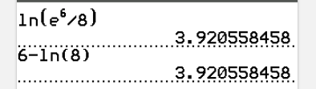

# Topic #3: Properties of Logarithms – The Power Rule

The power rule for exponents states:

This indicates that to raise a **power to a power** is to **multiply** the powers.

The Power Rule for logarithms is similar:

This also indicates that raising a power becomes multiplication.

For example, we can rewrite a logarithmic expression with a power to become one with multiplication:

*Example #1* – Expand the Expression

a) $\log_{b}{x^{4}}$

The base $x$ to the power of $4$ is an input to the operation “log base $b$” (which can be any suitable base); the power rule applies and the power of $4$ becomes a multiplier/coefficient:

b) $\ln{\sqrt{z}}$

The fractional power of square root is “one half”. The base $z$ to the power of $1/2$ is an input to the operation of the natural log; the power rule applies and the power of $1/2$ becomes a multiplier/coefficient:

c) $\log\left(t^{-5}\right)$

The base $x$ to the power of $-5$ is an input to the operation of the common log; the power rule applies and the power of $-5$ becomes a multiplier/coefficient:

# Topic #4: Properties of Logarithms – Using Multiple Rules

Some logarithmic expressions can be expanded by using multiple rules. Here are the three fundamental properties again:

Product Rule:

Quotient Rule:

Power Rule:

*Example #1* – Expand the Expression and Simplify when Possible

$$\text{a) }\log\left(x^{2}\sqrt{y}\right)$$

Rewrite the radical as a fractional power; there is a product rule and two power rules:

$$\text{b) }\log_{6}\left(\frac{\sqrt[3]{y}}{36x^{3}}\right)$$

Rewrite the radical as a fractional power; there is a quotient rule, a product rule in the denominator, and two power rules:

$$\text{c) }\ln\left(\frac{x^{2}z}{\sqrt{y+1}}\right)$$

Rewrite the radical as a fractional power; there is a quotient rule, a product rule in the numerator, and two power rules:

# Topic #5: Properties of Logarithms in Reverse – Condensing a Logarithmic Expression

The rules established above are a two-way street. We can expand a logarithmic expression into two or more terms, but we can also condense two or more terms into one expression. Here are the rules (again) in reverse:

$$\log_{b}{M+\log_{b}{N}=\log_{b}{(M*N)}}$$

$$\log_{b}{M-\log_{b}{N}=\log_{b}{(M/N)}}$$

$$N\log_{b}{M}=\log_{b}{M^{N}}$$

Consider the expression

$$2\log{x+\frac{1}{2}\log{y}}$$

We have two terms; the coefficients become powers (the half power can be written as a square root) and addition becomes multiplication:

*Example #1* – Condense the Expression

$$\text{a) }\frac{1}{3}\ln{y+2\ln{z-3\ln{x}}}$$

Rewrite the coefficients as powers; positive terms make up the numerator and negative terms make up the denominator:

$$\text{b) }6\ln{x-\frac{1}{8}\ln{z+\ln{y}}}$$

Rewrite the coefficients as powers (the coefficient for the third term is $1$, so we do not need to do anything); positive terms make up the numerator and negative terms make up the denominator:

$$\text{c) }\log{8}-\frac{1}{2}\log{x-3\log{y}}$$

Rewrite the coefficients as powers (the coefficient for the first term is $1$, so we do not need to do anything); positive terms make up the numerator and negative terms make up the denominator:

# Topic #6: Properties of Logarithms – Change of Base

Not all values of logarithmic expressions are rational numbers. For example $\log{15}$ is not a rational number, it is somewhere between $1$ and $2$ since $\log{10=1}$ and $\log{100=2}.$

Scientific and graphing calculators are programmed to give values for common logs (base 10):

$$\log{15≈}$$

Scientific and graphing calculators also evaluate natural logs (base $e$). Using a calculator, we can approximate values such as: $\ln{15≈}$

Most calculators do not directly evaluate other bases. For example $\log_{2}{15}$ is not a rational number, it is somewhere between $3$ and 4 since $\log_{2}{8=3}$ and $\log_{2}{16=4}$. However, most calculators do not give this value directly.

The Change of Base Property is the way around this issue:

The property tell us we can express the logarithm of base $b$ in terms of another base $a$. The two most convenient and useful bases are base $10$ and base $e$:

We can use either common logs or natural logs to evaluate other bases. For example,

$$\log_{2}{15=\frac{\log{15}}{\log{2}}≈ }\log_{2}{15=\frac{\ln{15}}{\ln{2}}≈}$$

We can also graph logarithmic functions other bases with this property. Suppose we want to graph $f\left(x\right)=\log_{3}{x}$.

Using change of base (pick either a common or natural base): $f\left(x\right)=\log_{3}{x}→f\left(x\right)=\frac{\ln{x}}{\ln{3}}$

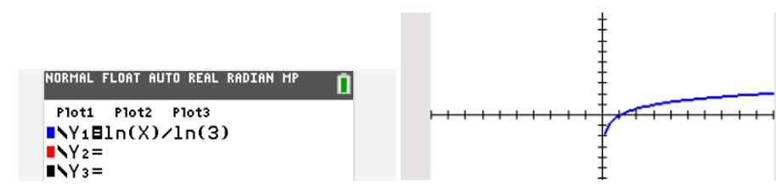

*Example #1* – Graph the following in your calculator using the change of base property.

$f\left(x\right)=\log_{4}{x}$

$f\left(x\right)=\log_{x}{4}$

$f\left(x\right)=\log_{9}{x}$

*Example #2* – Find the following in your calculator using the change of base property. Round to the nearest hundredth.

$f\left(x\right)=\log_{4}{9}$

$f\left(x\right)=\log_{9}{4}$

$f\left(x\right)=\log_{7}{10}$